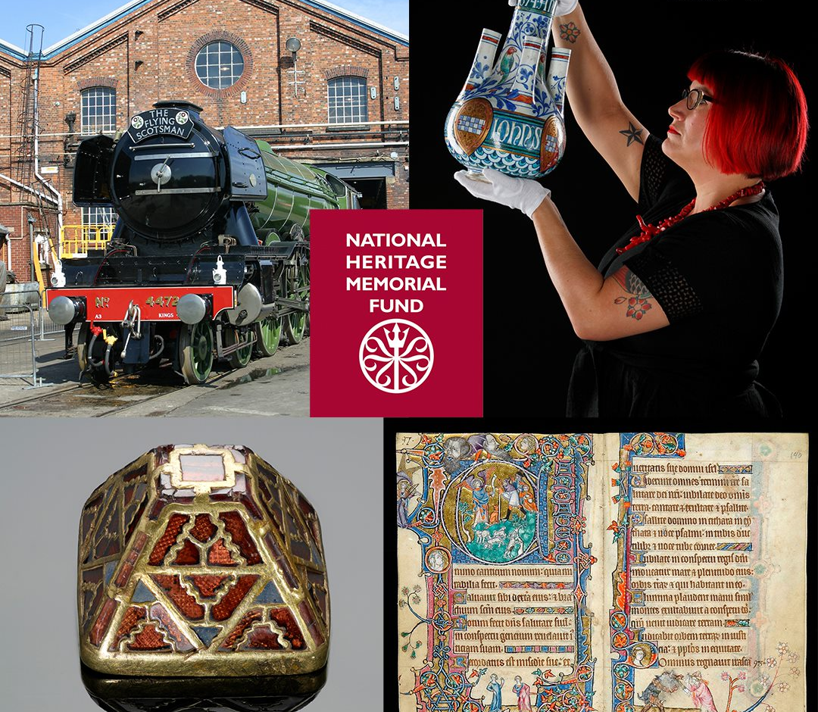
NHMF Panel recruitment
Information pack for applicants

About the National Heritage Memorial Fund
The National Heritage Memorial Fund (NHMF) was established in 1980 to save the most outstanding parts of our national heritage at risk of loss to the nation, as a memorial to those who have given their lives for the UK. The Fund has a current annual budget of £5 million. The National Heritage Memorial Fund (NHMF) is the fund of last resort for the nation’s heritage, coming to the rescue by funding emergency acquisitions.

NHMF has helped to save thousands of iconic heritage treasures for the nation including The Flying Scotsman, Henry VIII’s flagship Mary Rose and the Staffordshire Hoard.
The latest treasures to be saved for the nation are the sledge and flag from Ernest Shackleton’s British Arctic Exploration – one of the most important expeditions in British history. Find out more about this historic acquisition and our 40th anniversary on our news pages.

In 1994, the NHMF became the distributor of the heritage share of National Lottery money for good causes, which it now operates through the National Lottery Heritage Fund (‘The Fund’ formerly the Heritage Lottery Fund). These roles do not advise on Lottery funding.
In 2021 a new £40M fund was established, funded partly by DCMS and partly by NHMF, focused on saving nationally important heritage within the UK at risk as a result of COVID 19.

Please visit www.nhmf.org.uk for more information about the National Heritage Memorial Fund.

The NHMF Panel
The NHMF Panel is made up of up to eight heritage experts appointed by the NHMF Chair, including one Trustee. The panel is currently chaired by Ros Kerslake, the Chief Executive of the Heritage Fund.

The NHMF Panel meet four times a year to discuss the pipeline of up-coming cases which are seeking NHMF support. The NHMF Panel discuss how well cases meet the NHMF standards and recommend which are a priority for NHMF support. The Panel’s views on priority inform which cases are invited to submit full applications and are reported to the Board of Trustees when they make decisions on those applications.

During 21/22 and 22/23 the NHMF Panel will also discuss and prioritise approaches to the NHMF Covid Response fund; a £40m UK wide fund for nationally important heritage assets at risk due to the impacts of Covid-19. This fund includes the £20m Cultural Assets Fund, which is an allocation for England from the DCMS Culture Recovery Fund.

What NHMF can fund
NHMF can support outstanding nationally important heritage which is at risk of loss, or which is of particular memorial character.

Examples of heritage NHMF can support include:
- works of fine and decorative art;
- museum collections;
- archives;
- manuscripts;
- items of industrial, transport and maritime heritage; and
- historic buildings and land.

Projects involve buying, maintaining or preserving objects, collections, buildings or land that are of particular importance to the national heritage of the UK. We take into account designation as an indication that a heritage asset is of national heritage importance. We will consider un-designated heritage assets, but applications must make a case for their national heritage importance. In addition to being of importance to the national heritage, the heritage asset must also be in some way outstanding. This could be because of rarity, quality, association with a historic figure or event, or designations.

Who we are looking for
The Fund is looking to recruit up to six new NHMF Panel members.

The role of the panel member is to contribute to the panel providing expert advice to the Board of Trustees on one or more of the following topics:
- Industrial, maritime and transport heritage
- Archives and documentary heritage
- Decorative arts
- Fine art and the art market
- Archaeological heritage
- Built heritage and designed landscapes
- Natural heritage
- Museums and collections

Panel members provide expertise on one or more of the above areas in discussing a range of NHMF applications and potential applications. They advise the Board on the level of priority for funding a project taking into account the opinions and formal advice from experts and other agencies.

The role of Panel member represents an exciting and challenging opportunity for an individual with a strong commitment to, and enthusiasm for, the UK’s diverse heritage, to make a lasting contribution.

You will have:
- An expert level of skills and knowledge in one or more of the heritage areas listed above
- Proven experience and be an recognised leader in your particular field
- Strong connections within the sector
- A keen interest in the UK’s heritage.
- The ability to weigh up relative heritage significance.

Time Commitment
NHMF Panel members are expected to attend four meetings per year, plus time to read the necessary papers. Meetings generally last around 3 hours. The Panel has been meeting virtually since April 2020. In the future, meetings will be a mix of in person and virtual meetings.

Remuneration
NHMF Panel members will be paid a rate of £350 for each of the four NHMF Panel meetings. This will be paid in monthly instalments. This includes an allowance for time taken to read papers. The Fund will also pay travel and subsistence within our guidelines when attending meetings in person.

Term of appointment
The appointment will be up to four years in the first instance with potential to be renewed for an additional term.

How to apply
To apply, please send:
- a CV of no more than two sides of A4;
- a short supporting statement describing the skills and experience you would bring to our Panel.

Completed applications should be emailed to: decisionmakers@heritagefund.org.uk

If you have any questions about the process, please contact the email address above or if you have questions about the role of NHMF Panel member please contact Vanessa Wells, Head of NHMF (vanessa.wells@heritagefund.org.uk)

The closing date is Sunday 24 October 2021 at 11.59 p.m.

Diversity and inclusion
We are particularly keen to encourage applications from underrepresented groups on our panel. These include young people, people of black, Asian and minority ethnic backgrounds, people who identify as disabled or with long-term health conditions, people who identify as LBGTQ+ and people from lower socio-economic backgrounds.

We will be looking to recruit Panel members from all around the UK to ensure we have good representation across the country.

We will ask all applicants to complete a diversity monitoring form. Your data is not disclosed to the selection panel, but allows us to constantly evaluate any potential barriers to working with us and whether there are any changes we could make to encourage a more diverse field to apply.

Reasonable adjustments
If you would like a confidential discussion regarding any reasonable adjustments during the process, please also indicate this in the covering email or letter.

Supporting information
All applicants are expected to have adhered to the Seven Principles of Public Life.

Conflicts of Interest
If you have any interests that might be relevant to the work of the NHMF, and which could lead to a real or perceived conflict of interest if you were to be appointed, please provide details in your application and this will be discussed with you at interview.

Interview and selection
We aim to let you know if you have been shortlisted for interview by Friday 12 November 2021.

Interviews will be held by a panel of NHMF trustees and directors on 7 December 2021.

