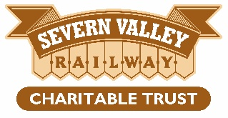

Position: Project Delivery Manager

up to six months contract

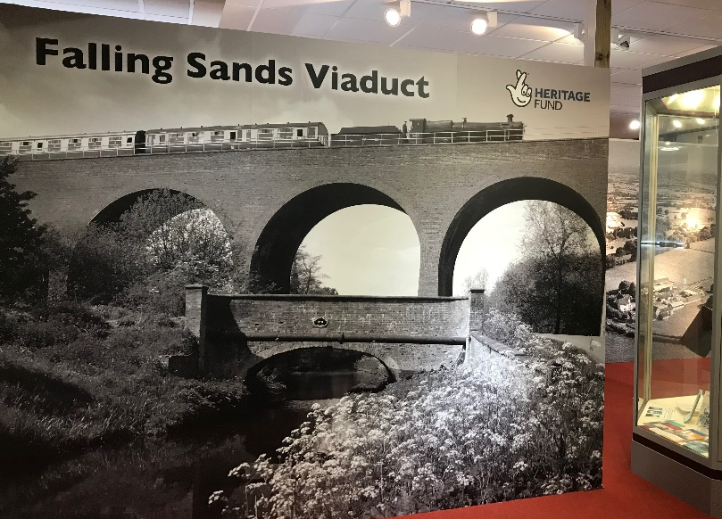

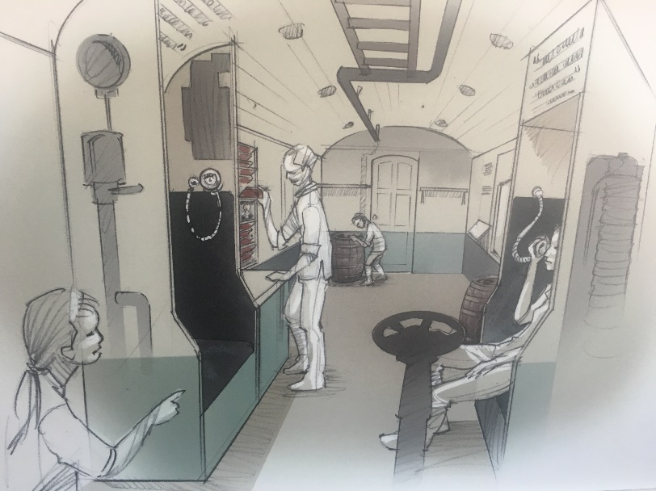

Project Delivery Manager
This is an exciting opportunity to join the Severn Valley Railway Charitable Trust and manage the final stage of the delivery of a £1.25m prestigious project funded by the National Lottery Heritage Fund, the restoration and education of the Severn Valley Railway’s Falling Sands Viaduct, situated in Kidderminster.
As project delivery manager you will have experience in:-
- project management, with strong skills in prioritising workload, keeping to tight deadlines, budgets and managing various people across different organisations.
- designing and delivering significant interpretation projects, closely supervising researchers to ensure the brief is met.
- strong interpretive copy writing skills.
- building educational activities for schools and the wider community (working with a dedicate project officer.)
- reporting to the National Lottery Heritage Funded project or similar.
- reporting to a range of people and organisations based on their requirements, both verbally and in written reports.
We are seeking an enthusiastic and dynamic project manager, with proven interpretation skills who is proactive and results driven, who will hit the ground running to deliver the final phase of the project, the activity plan.
This is your chance to join an amazing local charity that is committed to safeguarding the Severn Valley Railway for future generations.

Job Description

Position: Project delivery manager
Organisation: Severn Valley Railway Charitable Trust
Location: Flexible
Job Type: Part-time. 4-days a week, up to six months contract
Salary: £30,000 (pro-rata)
Holidays: 31 per annum including Bank Holidays (pro-rata)

Job Purpose
To manage the delivery of the final phase of the Falling Sands Viaduct project, focusing primarily on education, interpretation, community engagement and events. The role includes line management of project support officer and reporting to the National Lottery Heritage Fund (NLHF).

Main Duties

Duties and Responsibilities
- Oversee delivery of the remaining programme to include further interpretation, developing education offerings for schools and the community, ensuring the approved purposes and outcomes of the project are met.
- Working with the team, create the messaging and draft the copy for the new interpretation.
- Liaise with contractors, freelancers and local organisations to ensure project outcomes and evaluation reports are completed on time and to budget.
- Report to the NLHF through progress reports and payment requests.
- Manage the cash flow and project budget.
- Develop relationships with external partners and stakeholders to raise awareness and improve community engagement with the project.
- Line manage the part-time project support officer.
- Provide information to the Fundraising manager to keep donors updated.
Key Accountabilities
- Report to the Director of Development.
- Provide timely information on progress, including Heritage Fund reports.
- Perform within targets and timescales.
- Engage with staff to maximise the publicity and engagement of the project.
- Ensure that the capturing of any data meets the requirement of the GDPR Regulations.
- Follow the Trusts safeguarding policy and report any concerns in accordance with the safeguarding procedures.
- Work at all times with due regard to the policies and procedures of the Trust, including financial regulations.
- Carry out other tasks as reasonably required by the Director of Development.

Qualifications, knowledge and experience required
- Project management/delivery experience.
- Experience in creating interpretation to set outcomes.
- Interpretation copy writing.
- Delivering a project against set approved purposes.
- Reporting to NLFH or equivalent.
- Experience managing project budgets.
- Excellent skills in time management and prioritising workload.
- Trained and experienced in the use of MS Office software.
- Experience of motivating and managing volunteers and/or working with a range of people.

We offer
- Free parking.
- Subsidised meals.
- Flexible working hours, location, part working from home.

