House Manager
£32-35,000 P.A. dependent on experience
Full time
Benefits: pension; potential for estate accommodation

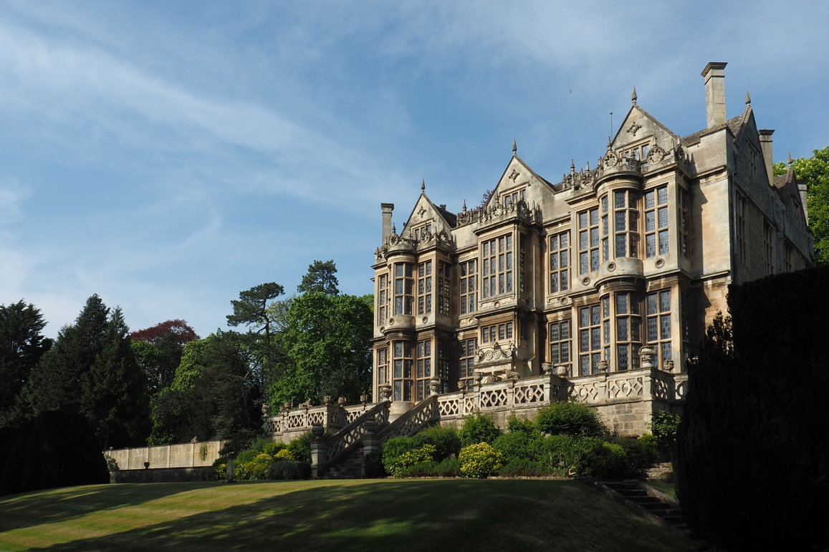
The Hall, Bradford on Avon

The Hall is a Grade 1 listed Jacobean property with 7 acres of garden set in the heart of the market town of Bradford on Avon, Wiltshire. The house and its collections tell the history of the Moulton family since the arrival in 1848 of Stephen Moulton bringing the rubber industry to the town right through to Dr Alex Moulton, the last resident of The Hall, and founder of the charitable trust. A celebrated engineer who designed the suspension systems that were fitted to 12 million cars (including the Mini) made between 1959-2002, and the iconic Moulton bicycle that is still made on The Hall estate today.

The Alex Moulton Charitable Trust was founded by Dr. Alex Moulton in 1977. Following Alex's death in December 2012, the remaining assets of the Moulton Estate – which includes The Hall itself, and a varied collection which includes historic furnishings (from the 17th to 20th centuries), Alex Moulton’s personal effects, papers, design models and archives, as well as archive material held by Wiltshire Archives Centre – passed to the Charitable Trust for safe-keeping, conservation and preservation. Since then, a great deal of background work has been carried out to assess and set out the future direction for the Trust and the Estate. In 2020, the Trust became a Charitable Incorporated Organisation (CIO) to support its future direction.

This is an exciting moment to join the Trust as we continue to develop The Hall and its estate and work to build an engaging visitor experience and public programme to enhance the educational, artistic and research potential of our site and collections.

Our Vision and Charitable Objectives

The Trust’s vision is to nurture and inspire future generations of innovating engineers and designers and to inform, excite and engage the community in the unique industrial legacy of the Moulton family of Bradford on Avon.

The objectives of the Alex Moulton Charitable Trust are to advance the education of the public, in particular (but not exclusively) in the subjects of engineering and design; to promote for the public benefit the study and appreciation of The Hall, Bradford on
Avon as a place of historical and architectural interest and natural beauty; and for the public benefit, the preservation and enhancement of The Hall, Bradford on Avon together with its ancillary buildings, contents, collections and gardens.

The role

The role of House Manager is a new position focused on managing The Hall’s important historic site and estate and overseeing the visitor experience and collections. We are seeking a proactive and energetic individual with significant experience of operational management, ideally in a heritage context, who will support The Hall’s development at a key moment in its history. You will manage a small team of part-time staff and volunteers including an Administrator, an Events Assistant, and a Gardener. You will be responsible for delivering our varied programme of outdoor events, house tours, venue hire and displays, and developing future activities. Overseeing site access and maintenance, you will work with and supervise contractors and caterers as required. Supported by an engaged team of Trustees, you will ensure the safety of our site, building, historic interiors and collection, and develop plans for their care and preservation.

Key responsibilities will include:
- Operational management of The Hall and its estate
- Acting as main site contact for contractors, visitors and partners
- Managing a small, dedicated team of staff, and liaising with key stakeholders, including site tenants
- Managing and growing our team of house and garden volunteers
- Responsible for allocating and managing budgets, reporting to the Chair of Trustees and preparing Board reports as required
- Taking a lead on building management, security and risk management, supported by the Trustees
- Developing and delivering activities, events and the public programme
- Delivering on the existing business plan and contributing to our Covid recovery
- Developing and enhancing procedures for the conservation, care and preservation of the collections and property, with guidance from Trustee Board
- Contributing to income-generating activities and funding applications as required
- Promoting The Hall’s events and activities through marketing and online, with the support of the team

Person specification

Essential criteria:
- Relevant degree, postgraduate qualification an advantage
- Demonstrable experience of operational management in a heritage or historic house context
- Commitment to and experience of delivering an excellent visitor experience, developing public programmes, exhibitions or displays and events for a range of audiences
- Demonstrable collections management experience
- Good understanding of compliance, procedures and risk management in a heritage context
- Experience of managing budgets, finances and good record keeping ability
- Excellent communication and stakeholder management skills
- Experience of managing staff and volunteers

Desirable criteria:
- Demonstrable interest in design, engineering and education
- Experience of contributing to funding bids and/or heritage development projects or capital projects

For further background on The Hall, Alex Moulton and the Trust’s activities please visit: www.moultontrust.org

To apply, please send a C.V. and covering letter outlining your suitability for the role to: moultontrust@gmail.com

Closing date: Thursday 1 April 2021, 5pm.

Interviews will take place online on Friday 9 April.

For enquiries or to schedule an informal conversation about the role, please contact us on the email address above.

