Exciting Evaluation Consultancy opportunity
(fixed term consultancy contract)
The Old Library and Museum, Memorial Avenue, Worksop, Nottinghamshire S80 2BJ

Aurora Wellbeing Centres are leading a new and exciting Heritage, Health and Wellbeing project and want to create a leading edge evaluation programme to support this work.

- Consultancy/Consultant opportunity

We would like to commission a consultant to work with us on the following project which has a number of strands:

- Develop innovative work exploring heritage and health which demonstrates the potential for improving the wellbeing of clients diagnosed with cancer and Long-Term conditions and the local community.
- Develop a heritage activity programme, volunteer programme and partnerships to significantly broaden opportunities for engagement with clients of Aurora and the local people of Bassetlaw.
- Create a new heritage space for the people of Worksop to celebrate their heritage within the centre to including physical displays and an innovative virtual museum to tell stories of the area and the building.
- Renovate, conserve and restore the Grade 11 listed 1938 Old Library and Museum building, creating a multi-use centre, accessible to all.

- Contract

This post is offered on a consultancy contract funded through the National Lottery Heritage Fund. The Evaluation Consultancy will be accountable to Aurora Wellbeing Centres, who will act as the client and set out all the requirements of the role.

The consultancy will be required to work collaboratively with Aurora Wellbeing Centres Board, staff and all project partners and stakeholders to develop the project and deliver all targets to a high standard.

We envisage that the evaluation consultant will work as part of a team approach to evaluation. We would expect the Consultant to have skills in health and heritage and wellbeing evaluation be able to demonstrate the following:

Experience and skills:
- Experience of evaluating grant aided projects following the requirements of the National Heritage Lottery Fund.
- Experience of working with a professional team.
- Knowledge of the heritage sector or visitor attractions.
- Experience of community engagement.
- Understanding of the Aurora Wellbeing Centres and appreciation of our aims and anticipated outcomes.
- Excellent interpersonal and communication skills.
- A high level of advocacy and negotiating skills.
- Demonstrable ability to work collaboratively and forge effective working relationships.
- Ability to identify appropriate advice and information.
- Good time-management skills.
- Excellent IT skills.
- A good standard of written and spoken English.

Attributes and aptitudes:
- A current DBS check.
- Driving Licence and access to a vehicle.
- Public Liability Insurance.
- Leadership.
- Ability and willingness to work outside normal office hours.

3. Delivery
The consultant will be expected to have a collaborative approach and agree an evaluation Strategy, schedule/framework as well as any changes with the client prior to implementation.

All ensuing graphics & designs will be assigned to the ownership of the Aurora Wellbeing Centres for copyright purposes.

- Scope of the work

The work to be undertaken in the delivery stage of the project will include:
• Co-design of an evaluation strategy with the Aurora project team to include a full summary of projected health, wellbeing and heritage outputs and outcomes. Develop a framework and timetable with an action plan for evaluation. This is to be a formative evaluation programme beginning with confirmation of the strategy and followed by a mid-term review and report (to assess outputs and outcomes to that point, facilitate reflection and amend strategy if required) and draft and final reporting. The evaluator will be expected to create a mid-term report and attend meetings as required.
• Consultation with all project partners to assess what data has already been collected and establish mechanisms which project staff and or the evaluator can use to collect further quantitative and qualitative data to evidence whether and how the project is going, lined to project outcomes.

- Co-develop and complete a final evaluation report with the Aurora project team as per NLHF Evaluation Guidance: https://www.heritagefund.org.uk/funding/run-your-project
that will include:
  - Background information on the Aurora Wellbeing Centres project and the local and social context.
  - Baseline information for the outputs and outcomes.
  - A review of the methodology of the project.
  - A full report on the results of the scheme and what has been achieved against set targets.
  - An assessment of outcomes.
  - Conclusions and recommendations.
  - Appendices with further details on quantitative and qualitative information gathered.
  - Lessons learnt on capital and activity delivery

- Time allocation

Time allocated to the delivery of the brief is not prescribed but should be sufficient to achieve the scope of work. Please indicate the level of time resource that would be allocated to this role in your tender.

Aurora Wellbeing Centres is an experienced Health, Wellbeing and community services provider and we seek to maximise opportunities for the continued professional development of our staff through our projects. As part of the project, the Evaluation Consultant will be expected to work collaboratively with team members in order to facilitate this but will be responsible for the delivery of the scope of this brief.

- Budget

This post will not be salaried/contracted, and the price should be based on a fixed fee including all related expenses. The maximum fee available for delivery will be £13,500 (excluding VAT).

- Timetable

Evaluation Consultant role advertised | 21st January 2020
Deadline for submission of applications | 5pm,18th February 2020
Interviews held | To be confirmed
Appointment of professionals confirmed | To be confirmed

- The Old Library and Museum Building: Historic Significance

The Old Library and Museum building currently houses the Aurora Wellbeing Centre serves as a focus for a number of different heritage strands, including the history of the building itself, the former museum collections, the history of the library service in Worksop, the history of the town as a whole and people’s memories of the Old Library and Museum.

The building is a 1938 Grade 11 listed building by J. Haslam, a local architect (listing ref: 1370103). The style followed a continental idiom influenced by the Dutch modernist architect Willem Dudok and echoing the work of Gunnar Asplund at Stockholm Central Library (1924-8). The Old Library and Museum is situated on the edge of the The Canch, a park given to the people in 1912 and expanded to include the Memorial Gardens in 1938 to accommodate the new Library and Museum.

The building is architecturally unique in the area and a rare example of civic architecture efficiently combining both museum and library services, whilst still celebrating strong municipal values. The architectural design adopted by many authorities during the inter-war years was a Neo-Georgian style, however this building combining traditional and modern, is one of only a handful of surviving municipal examples of art deco style in the Midlands.

The building is a well-oved feature of the town’s landscape, with many local residents remembering it fondly in its former incarnation. The museum went through a number of changes over the decades. The natural history and geology collections were transferred to Doncaster Museum in the 1960’s and the majority of the remaining local and social history collections were transferred to Bassetlaw Museum in 1983.

Aurora Wellbeing Centres intend to deliver conservation repairs to a high standard and a conversion which takes full account of the significance of the building. All professionals appointed to this project will be required to meet these standards.

- Description and Current Condition

The building is in a poor condition and in need of repair. Aurora Wellbeing Centres moved into the ‘mothballed’ building in 2011 and have undertaken cosmetic work to enable the building to be functional.

Please refer to the Full Condition Survey for details of the current condition and schedule of works for the repairs proposed.

- Ownership and current status

Bassetlaw District Council own the property and lease it to Aurora Wellbeing Centres on a ‘peppercorn rent arrangement’. Access can be arranged through our office if a site visit is required in advance of submitting your tender.

It is viewed as essential for the entire scheme to be delivered in a phased approach to prevent any negative impact of the amenity of people using the building and in order to ensure the financial viability of the proposed use.

Planning Permission and Listed Building Consent have been granted for this scheme.

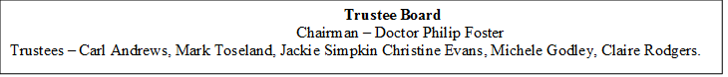
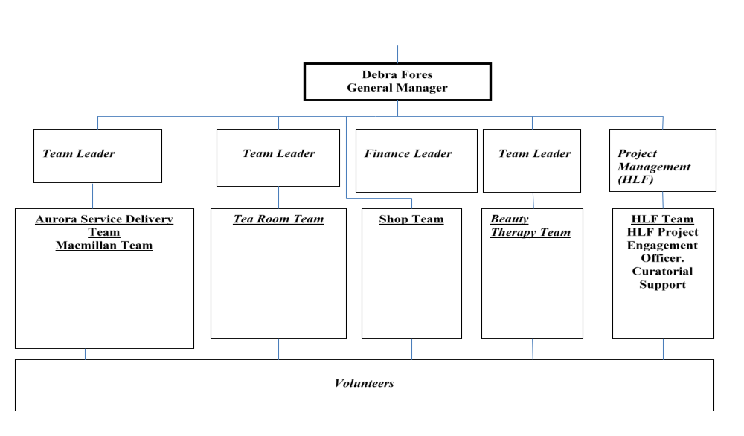
- Project Management Structure – Aurora Wellbeing Centre, Worksop 2020

- Application Process

All applications should be submitted by 5pm,18th February 2020 by email to: admin@aurorawellbeing.org.uk

Please supply the following information:

- Your proposed fee for the project the resources being allocated

- Details of previous experience and CV. If applying as an organisation, please supply the CV of the nominated lead officer. Please highlight your experience of evaluating Heritage Lottery Fund projects.

- A summary of your understanding of the brief.

- A minimum of 2 references.

- Assessment of Applications

Tenders will be assessed on the basis of 60% quality, 40% cost.

Quality will be assessed on the following criteria:
- Resources
- Experience
- Key Personnel
- Community engagement

Interviews will be held following the shortlisting process and all applicants will be
informed of the outcome following confirmation with the successful candidate.

If you have any queries or require clarification, please contact Debra Fores initially
by email on admin@aurorawellbeing.org.uk.

- Contact details

Aurora Wellbeing Centres
The Old Library Building
Memorial Avenue
Worksop
Notts
S80 2BJ
Email:admin@aurorawellbeing.org.uk
Telephone: 01909 470985

