Tweedsmuir Destination Development Project
This is an innovative project to highlight and promote the opportunities to explore the outstanding landscape, fascinating history and little-known heritage assets of the area. The project has been developed by the Tweedsmuir Community Company (TCC) and is funded by grants from the National Lottery Heritage Fund (NLHF) and the Scottish Borders Council Community Fund.
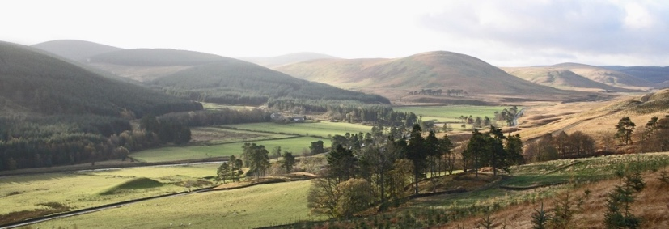

Background and parallel development
The TCC was formed in 2007 to save and develop the 400-year old Crook Inn as a vital community resource after its closure in 2006. It purchased the Crook Inn in 2013 after an energetic appeal, then the rest of the land and buildings at the site in 2016. Due to the high capital costs the TCC has now opted for a phased approach to redevelopment. Architects plans have full planning consent. Separate funding applications are being made for construction work to deliver a Crook Inn Café, then bunkhouse and camping facilities, and, ultimately, the restoration of the Crook Inn.

The Destination Tweedsmuir Development Project has the primary purpose of raising the profile of Tweedsmuir and the attractions of the Upper Tweed as a visitor destination. The project will provide different ways to discover and access these attractions by both physical and digital means.

The TCC will employ a part time Heritage Development Officer and commission professionals who will work with 3 community groups (walking and cycling group; heritage and landscape group; communications and marketing group).The plan includes the production of signage which will be installed on the site of the Crook Inn and elsewhere. A range of themed walks and cycle routes will be mapped and an App and audio trail created that can be downloaded by visitors. Heritage talks/events are planned. A new website will host a user-friendly, online resource displaying a digital archive and visual tour of local heritage sites. (an eco-museum: ‘a dynamic way in which communities preserve, interpret, and manage their heritage for a sustainable development’).

The project will be community-driven. The outcome will be that more people will discover the fascinating heritage and landscape of the area which will be clearly identified and better explained. The project will attract tourism, important in making operation of the café, bunkhouse at the Crook sustainable.
The proposed start is Oct/November. 2019 with completion June 2021. Total estimated cost is £76,000
.

